SFD's Intervention in feeder Roads

It is estimated that 60,000 km of earth rural roads in Yemen had been constructed mainly by local cooperatives during the seventies and eighties. This is in addition to thousands of kilometers of earth roads, which have been used by local communities. However, this is not enough to fulfil the rural communities need.
Yemen has a great number of settlements reaching 106,000. This requires a big network of roads to connect these scattered settlements together.
In addition, those settlements mostly scattered in difficult topographic areas with hard access, which makes it difficult to construct roads.

SFD 's Policy:
Feeder roads are considered important in improving the living standards in rural areas for the following reasons:
Connect remote areas with the civil centers.
Facilitate access to services such as health and education services.
Facilitate marketing rural agricultural products to urban regions.
Reduce cost of transportation of goods to rural areas.

Scope of SFD Intervention:

The scope of SFD intervention is to construct feeder roads and rehabilitate old ones to create job opportunities, which will improve targeted rural communities living conditions. SFD supports small-scale labor-intensive works through:
Rehabilitating access roads and drainage structures from damages by (building culverts, retaining walls, ditches, inlets & outlets).
Constructing and maintaining of alleys and paving footpaths by stones (riprap).

SFD Methodology & Working Procedures

People of the community or NGOs apply for financial support from the SFD.
In the case of eligibility and when the request meets SFD’s conditions and criteria, and sufficient fund allocations are available, SFD conducts a field visit to evaluate the need for the project and to ensure community participation and annual maintenance.
A technical, economical, and social study of the project is conducted to ensure SFD goals are achieved.
Once a complete study is prepared, the framework, its accessories, overall cost, and beneficiaries’ contribution are specified.
When the screening committee approves the project, the tender document is prepared.
SFD commence and supervise the implementation process.

Conditions of Eligibility

Socio-economic conditions:
Justified Socio-economic situation for SFD intervention.
Willingness of the beneficiary groups to contribute to the cost of the construction and the commitment for maintenance.

Other conditions:

Serve the biggest possible number of beneficiaries at a cost-effective way.
Conditions of roads and type of interventions.
Cost effectiveness of the interventions.
The annual cost for maintenance.
The alternative ways for passenger and goods. transportation

July - September, 1999
SFD
Newsletter
Social Fund for Development Newsletter
30 United Nations ST.
P.O. Box 15485
Sana’a, Republic of Yemen
Tel.: (967-1) 240417
Fax: (967-1) 243173
E-Mail: sfd1@y.net.ye
Screening the Year 2000 Projects

The SFD started practical measures in preparing the year 2000 work-plan. The screening phase of requests submitted by local communities was improved further to meet the challenge of targeting the poor by using poverty indicators down to the Uzla level. The initial office screening stage was completed. It resulted in defining Uzlas requiring further surveys to assess their development project’s needs. Field assessment is of special importance since its outcomes determine the location, type and size of SFD intervention.

On the 25th of August 1999 a field screening orientation workshop was held for local consultants with experience in field surveys. It started by giving background information on the SFD, its goals, funding criteria, policies, and field study steps. Then the field screening process that aims at raising community participation in defining their needs was presented. After the workshop several groups were assigned to conduct field assessment for the targeted Uzlas. During the month of October, these groups are expected to submit the project appraisal reports, which rate the requests according to the priority need of the community. Projects for the year 2000 are determined based on these reports.

Capacity Building Program News
During the third quarter of this year a number of programs and activities have been achieved including:

(1) Training Courses
A- Organizing the Accounts of Agricultural Cooperatives – Course No3:
The course was the third in a serie of courses in this field. It was held in Taiz for 24 trainees among them 3 females. The participants represented agricultural cooperatives, associations and programs in Hodeidah and Ibb, which implement SMED income generation programs. A female participant from the Capacity Building Unit attended the training as well.

B- A Training Course in Agricultural Marketing:
The Course was held in Taiz for 22 trainees working in the field of Marketing and representing the Federation of Agricultural Cooperatives and its branches in a number of governorates as well as other institutions. The course provided new and developed know-how in agricultural marketing, in addition to the training of trainers.

C – Other Programs and Training Activities:
The SFD, through Capacity Building Unit, also financed or co-financed programs and training activities related to other parties inside and outside the SFD. These included a Workshop enabling women to start their own business, a course for training consultants in environment education related to health and education projects, and a program to complete surveying 145 areas within the National Poverty Survey.

(2) Capacity Building Projects: Several projects were approved in the governorates of Taiz, Abyan and Sana’a City including financing two child libraries. This is in addition to projects for other governorates that will be implemented with effect from the 4th quarter of the year.

- (3) Consultancy Services: It has been agreed to provide consultancy services related to supporting the National Program for Productive Families and designing a training Program in
- the principles of organizing the accounts of associations and
- NGOs.

News and Events
Editorial
“Operating Cost” has been subjected to a great deal of discussion lately. In most cases, this topic was not discussed in a clear and proper manner despite the good intentions of those who raised it.

Argument on such a topic would lead to no-where if there were no an agreed upon definition of “operating cost”, based on acceptable accounting standards with proper understanding of the nature and characteristics of different interventions. It is also misleading to separate operating cost from outcome and performance quality.

This topic is of great importance because it reflects the efficiency of the different institutions. It could be used as a tool for measuring the comparative advantages of new institutional arrangements as represented by SFD and Implementation Units. Therefore, the SFD proposed to assign a consultant with experience in this field to study this matter. The results of this study will be of a great assistance to the decision-makers in their evaluations. This could in general contribute to a change in the performance of Public Service.

We in the SFD believe that the SFD follows an appropriate approach toward current expenditure in general. This will clearly lead to satisfactory results and will have a positive impact on SFD performance in the future.

Operating cost tend to be high in the first years of the life of any new organization, however, it has been found that SFD’s operating cost were rather low.

The SFD Board of Directors’ Second Meeting for 1999

On the 12th of July 1999 Dr. Abdulkarim Al-Iryani, The Prime Minister and Chairman of the SFD Board of Directors chaired the second meeting of the Board for 1999 at the Cabinet’s Premises. The agenda of the meeting included two main subjects: the auditor’s report and the financial statements for the year ended 31 December 1998 and the draft budget for the year 2000 which the BOD approved and considered to be a qualitative improvement in the SFD performance. The BOD also reviewed the actual SFD performance as well as the on-going coordination and cooperation with Government competent organs. The On the other hand, the BOD approved the appointment of an auditor to audit the SFD activities for the year 1999.

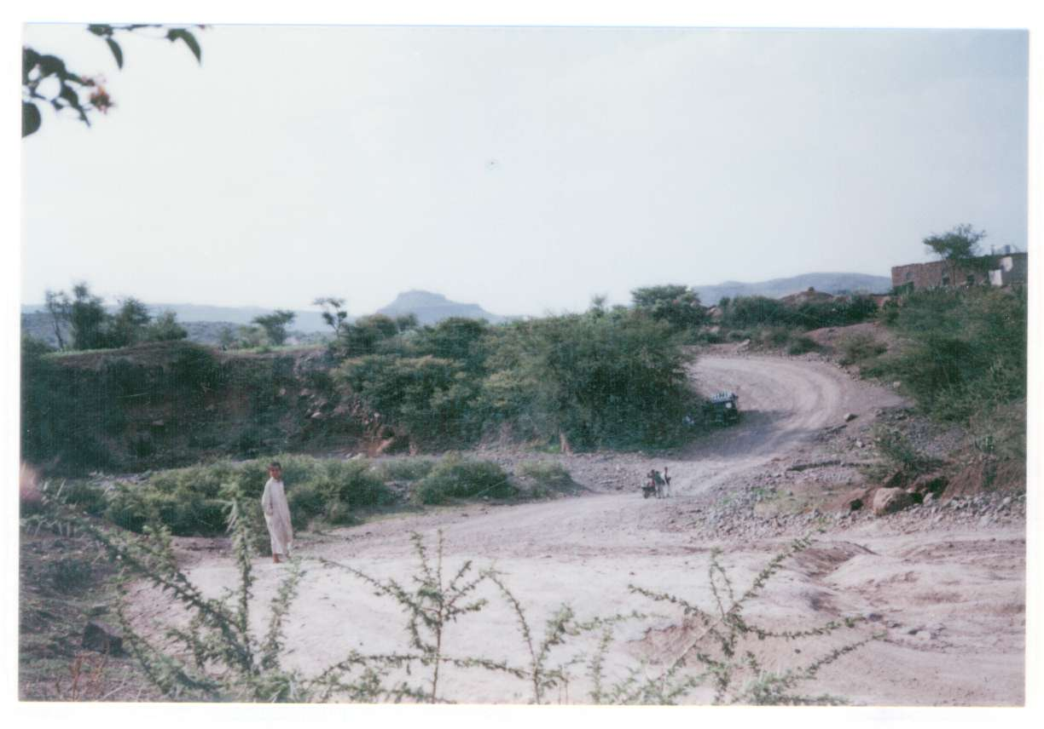
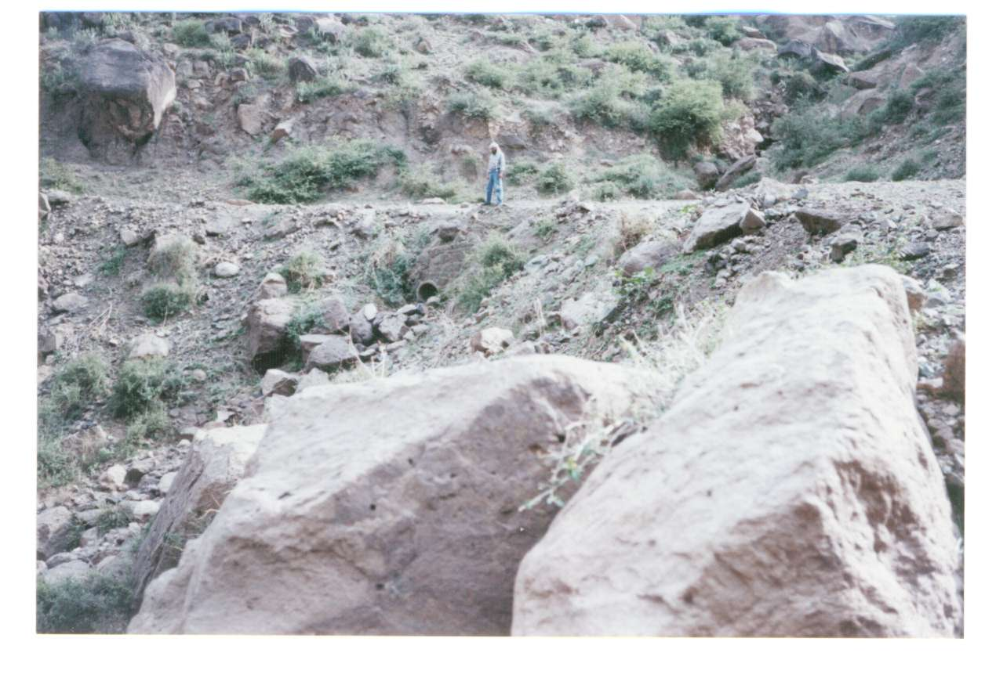

Expected Beneficiaries of the Third Quarter
Indirect Beneficiaries | Direct Beneficiaries | Group
5,785 | 28,071 | Men
4,897 | 29,418 | Women
9,296 | 44,939 | Boys
3,426 | 35,363 | Girls
23,404 | 137,791 | Total

Expected Direct Beneficiaries of the Third Quarter

Investment by Sector (3rd Quarter/ 1999)
Percentage | Investment ($) | No. of Projects | Sector
%63.11 | 3,416,784 | 77 | Education
% 7.28 | 394,200 | 7 | Health
%19.07 | 1,032,457 | 14 | Water
%4.56 | 247,031 | 3 | Roads
%5.97 | 323,420 | 12 | Capacity Building
%100.00 | 5,413,892 | 113 | Total

The beneficiaries and job opportunities tables illustrate the number of beneficiaries and work opportunities of SFD programs and projects during the third quarter of 1999.

SFD Accumulated Investment and Disbursement till 30/09/99 According to Governorate

Percentage of Disbursement | Disbursement ($) | Commitment ($) | No. of Projects | Governorate
%39.83 | 687,429 | 1,725,855 | 39 | Sana’a Capital
%50.09 | 2,020,961 | 4,034,938 | 93 | Sana’a
%54.10 | 681,373 | 1,259,473 | 18 | Aden
%57.89 | 2,780,341 | 4,802,917 | 88 | Taiz
%42.14 | 1,620,659 | 3,845,457 | 42 | Hodiedah
%34.76 | 586,491 | 1,687,106 | 26 | Lahj
%50.37 | 1,442,789 | 2,864,283 | 47 | Ibb
%44.57 | 376,887 | 845,598 | 13 | Abian
%32.65 | 837,623 | 2,565,467 | 44 | Dhamar
%34.77 | 314,648 | 904,972 | 20 | Shabwah
%29.78 | 833,932 | 2,800,110 | 53 | Hajjah
%58.67 | 491,952 | 838,472 | 17 | Baidhaa
%69.60 | 1,528,102 | 2,195,611 | 38 | Hadhramout
%36.52 | 302,688 | 828,833 | 13 | Saadah
%50.07 | 538,808 | 1,076,007 | 20 | Mahweet
%57.76 | 560,229 | 969,882 | 16 | Maharah
%57.44 | 475,480 | 827,825 | 14 | Maareb
%50.65 | 166,766 | 329,261 | 5 | Al-Jawf
%47.37 | 117,115 | 247,243 | 13 | More Governerates
%47.23 | 16,364,274 | 34,649,310 | 619 | Total

SFD Accumulated Investment, Disbursement, Number of Expected Beneficiaries, and Job Opportunities till 30/09/99 According to sector
Job Creation |  | Beneficiaries |  | Sector
Permanent (person) | Temporary (person-day) | Indirect | Direct
3,161 | 743,480 | 37,662 | 220,978 | Education
839 | 117,620 | 48,906 | 394,829 | Health
162 | 145,647 | 9,108 | 295,462 | Water
2 | 27,351 | 60,000 | 14,003 | Environmental Activities & Sewerage
0 | 12,592 | 6,186 | 17,946 | Roads
42 | 18,809 | 390 | 4,884 | Capacity Building
154 | 2,096 | 59,942 | 10,875 | Micro Enterprise
4,360 | 67,595 | 222,194 | 958,977 | Total

Disbursement  ($) | Commitment  ($) | No. of Projects | Sector
10,188,354 | 20,181,909 | 406 | Education
1,731,868 | 4,944,205 | 83 | Health
2,407,948 | 5,503,265 | 64 | Water
293,117 | 590,241 | 6 | Environmental Activities & Sewerage
5,876 | 247,031 | 3 | Roads
356,777 | 962,572 | 44 | Capacity Building
1,380,333 | 2,220,087 | 13 | Micro Enterprise
16,364,274 | 34,649,310 | 619 | Total

Expected Job Opportunities Created (3rd Quarter/ 99)
Temporarily  (Person - day) | Permanent  (person) | Group
183,618 | 221 | Male
1,693 | 59 | Female
185,311 | 280 | Total

Water Harvesting in Thamood Area
Al-Mukala Branch
Yemen is a dry country in which water scarcity is a big challenge facing most of the Republic districts. In many areas imbalance between the exploitation and recharging of ground water causes draw down of aquifers and groundwater quality deterioration.

In many valleys most of the rainwater escapes to sea or disappear in deserts. Water ponds excavated in the natural impermeable soil at bottom of valleys, as the situation in Thamood district / Hadramowt and which are called curfans, is one way of rainwater harvesting.

SFD Experience with Rainwater Harvesting
in Thamood Area:

Despite the severe need of water in Thamood area, rainwater in seven big valleys of the district pours in Ar-Rub Al-Khali desert. SFD has
participated in rainwater
harvesting through
excavation of 7 curfans
of 6000to 10000 cubic
meters in the area to
preserve water for
domestic consumption
and animal watering.

Small and Micro Enterprise Program News

Evaluation of Abyan IGP:
The income-generating program in Abyan was established in cooperation with Al-Darjaj Agricultural Cooperative. The program provides loans and veterinary services to the poor in Khanfar district. By the end of September 1999, the program has distributed loans in the form of livestock, medicines, and fooder to 297 clients for more than YR 13 million. During September a mission has evaluated the performance of the program in the first phase, during which program staff rehabilitation and training were completed. Credit systems were set up and 319 loans were granted. The conclusion of the mission indicates that the program was widely accepted in the area by clients. Some clients were able to benefit from the services provided and were able to reinvest.

One of the female borrowers with her children
browsing livestock she obtained from the project.

Saih Micro Credit Program:
Saih program provides its services to the people in Saih – Anes area. The program provides its services in the form of loans to farmers in the area. In March 1999, the program started by distributing loans for potato growers. Starting July, farmers began repaying their loans. At the same time, many have taken loans for tomato. The program is expected to expand in the coming period by offering loans for animal raising. The program is carried in cooperation with Al-Saih Cooperative.

Savings and Credit Program – Aden
A Workshop in Home Economics
During The month of August the Women Savings and Credit Program has organized a workshop in home economics for group members and their husbands. The number of groups who received assistance from the program reached 18 with a total of 500 members. The project is planned to start distributing loans in October 99.

Ladies with their husbands in home economics workshop

Marawe’ah Income Generating Program:
The program has continued providing services to the poor in Marawe’ah area. In the previous period the program started diversifying its loan portfolio by giving loans for sheep raising in addition to cattle fattening. Continuous rains in the area have increased demand for loans from the project.

Achievements of the Third Quarter of 1999
Investment:
During the third quarter of 1999, SFD has made a commitment to 113 projects with a total investment of 5.4 million dollars. The following table shows that 60% of the total investment is distributed among 5 governorates (Sana’a, Taiz, Hodeidah, Dhamar, and Shabwa).

On the other hand, the sectoral distribution of investment table indicates that the education sector remains in the lead. It occupied %63 ($3.4 million) of the investment followed by the water sector with %19.

Investment by Governorate (3rd quarter/ 1999)
Percentage | Commitment ($) | No. of Projects | اGovernates
5.00 | 270,624 | 8 | ٍsana’a City
12.51 | 677,459 | 17 | ٍsana’a
9.76 | 528,413 | 16 | Taiz
15.48 | 837,826 | 13 | Hodeidah
8.20 | 444,070 | 7 | Lahj
5.43 | 293,916 | 5 | Ibb
5.70 | 308,492 | 4 | Abyan
10.59 | 573,500 | 11 | Dhamar
6.43 | 347,985 | 6 | Hajja
2.61 | 141,136 | 3 | Baidhaa
2.07 | 112,195 | 2 | Sa’ada
1.29 | 69,867 | 2 | Mahweet
4.14 | 224,287 | 4 | Mareb
9.57 | 518,026 | 10 | Shabwa
0.58 | 31,325 | 1 | Hadhramout
0.64 | 34,771 | 4 | More Governorates
100.00 | 5,413,892 | 113 | Total

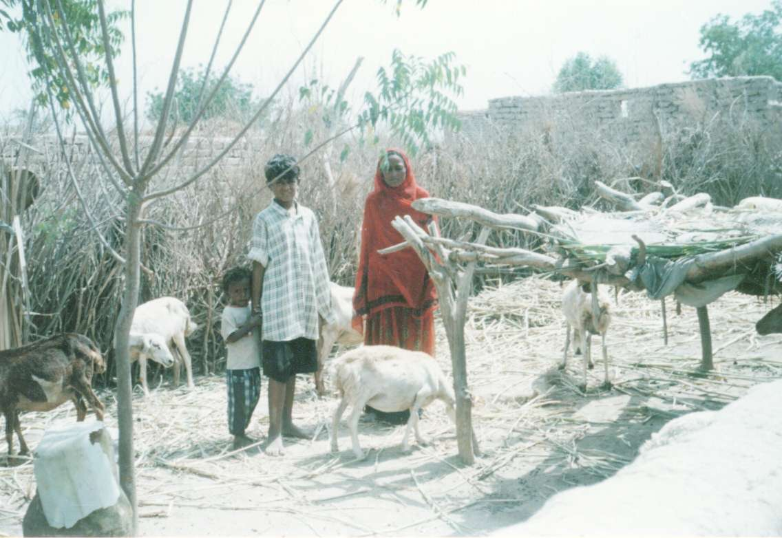
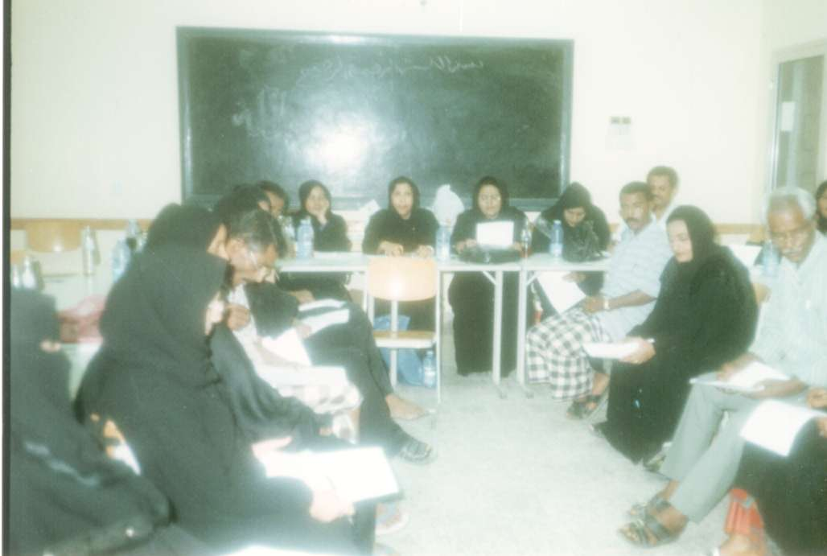
Investment by Governorate (3rd Quarter)

